Information and Signposting Officer Update
Website.
We have had a total of 3,452 new users between 1st July and 30th September. We have a footfall each day of anything from 6 users to 60 users. On 29th September we had 728 visits – maybe due to the advertisement of our new website at our Annual Public Meeting
Social media.
Our social media reach has been lower than normal over the past few months, this is due to fewer posts being shared. We had been concentrating finalising the graphics and layout of the Guided By You report. However, we did see a jump in
The caption read.
Not the usual work wear for Alexia, Paul and Melissa!
Thank you to the Midland Met University Hospital for the tour

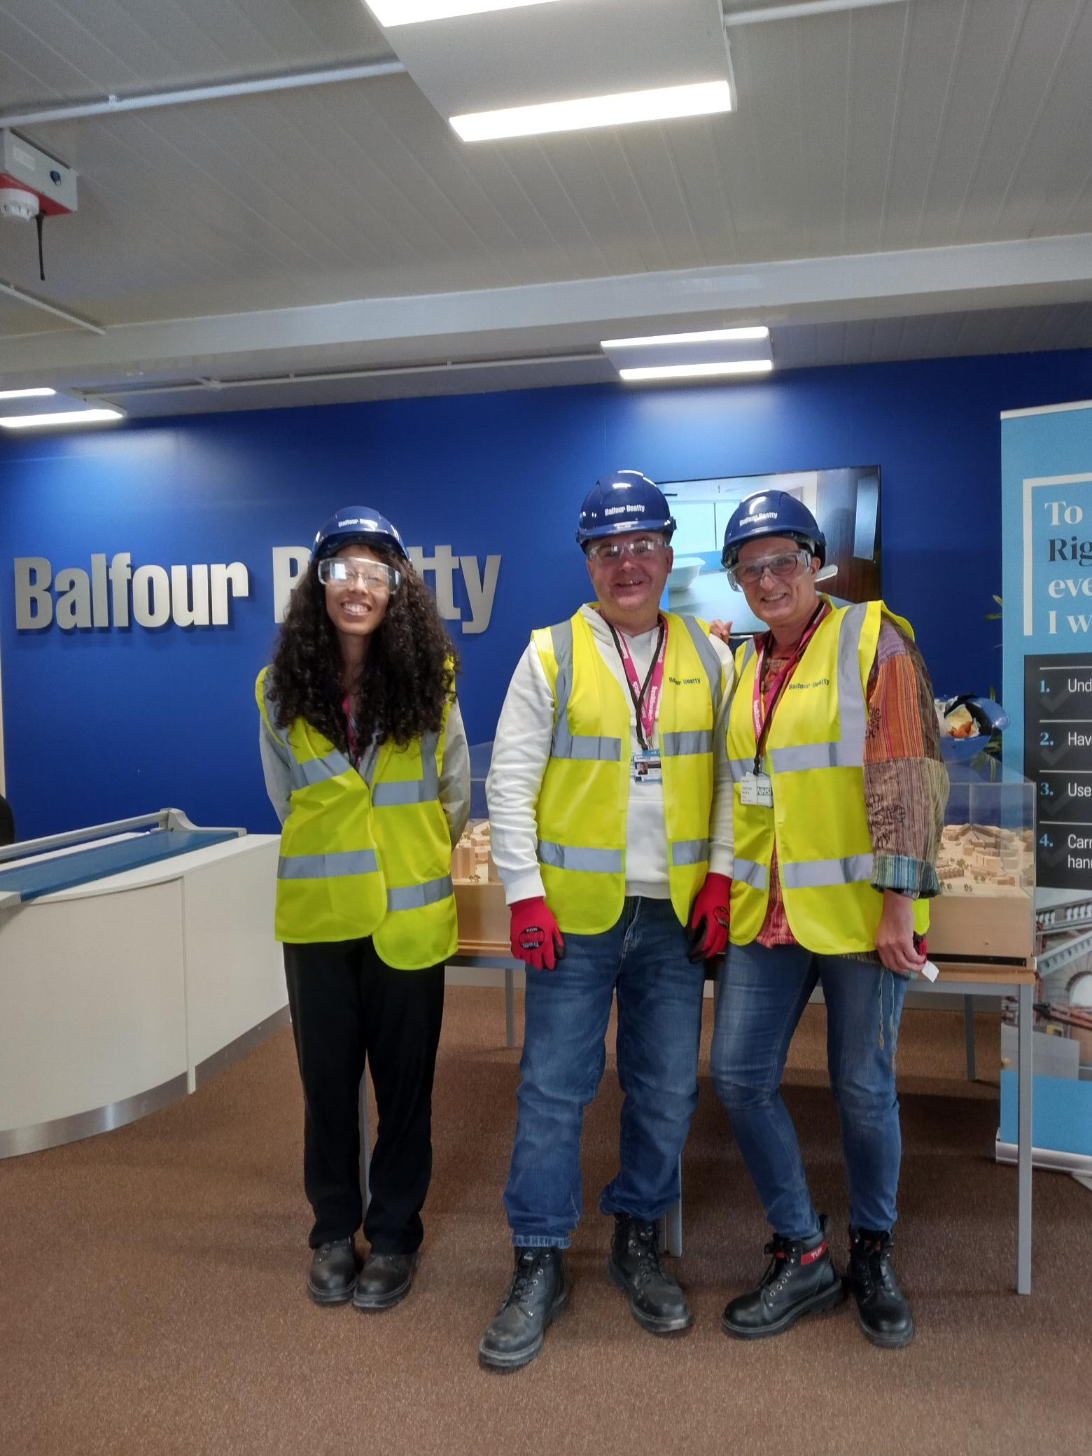

Instagram also saw a jump in post reach on 24th July when we asked if people would like to share their stories on Autism during pregnancy.
On the day of our Annual Public Meeting, we shared a post on Anitas story of a Patient Moving to a Care Home. Picture and caption below.

“Very, very powerful, and emotional story of a patient moving to a care home and the issues they faced. Thank you, Anita, for sharing this. If you would like to read this story, you can head over to our website and look at our reports section.
https://www.healthwatchsandwell.co.uk/report/2022-11-
15/case-study-patients-journey-moving-care-home”.
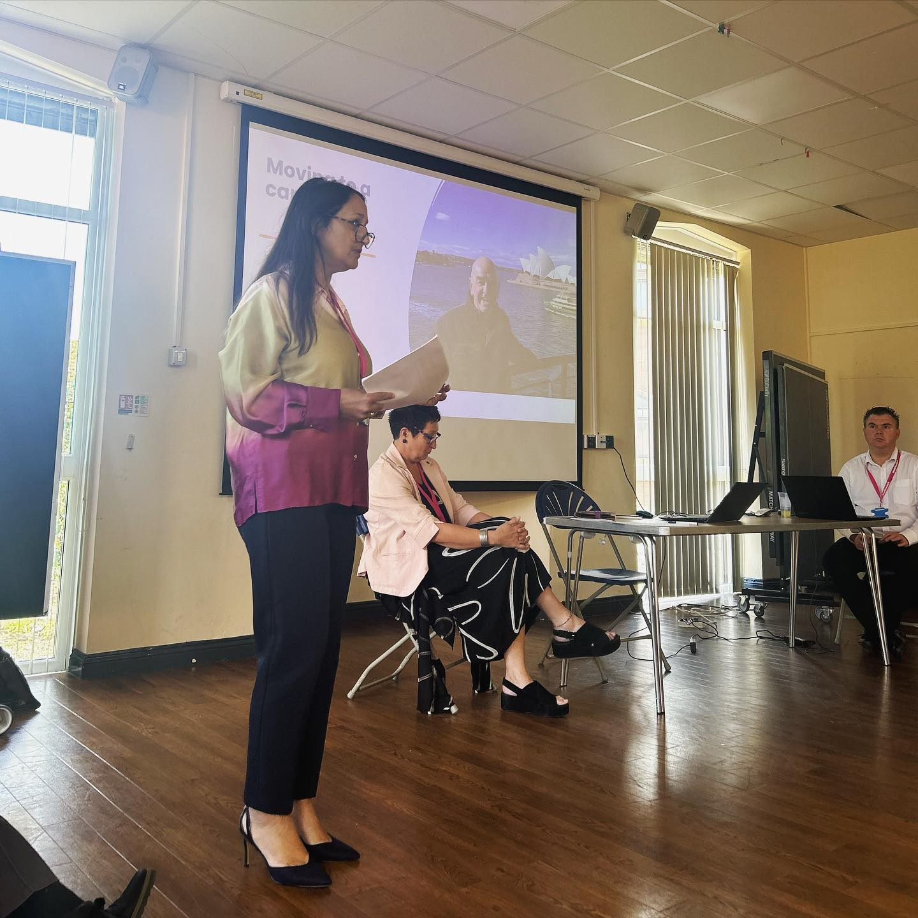
Snap shot
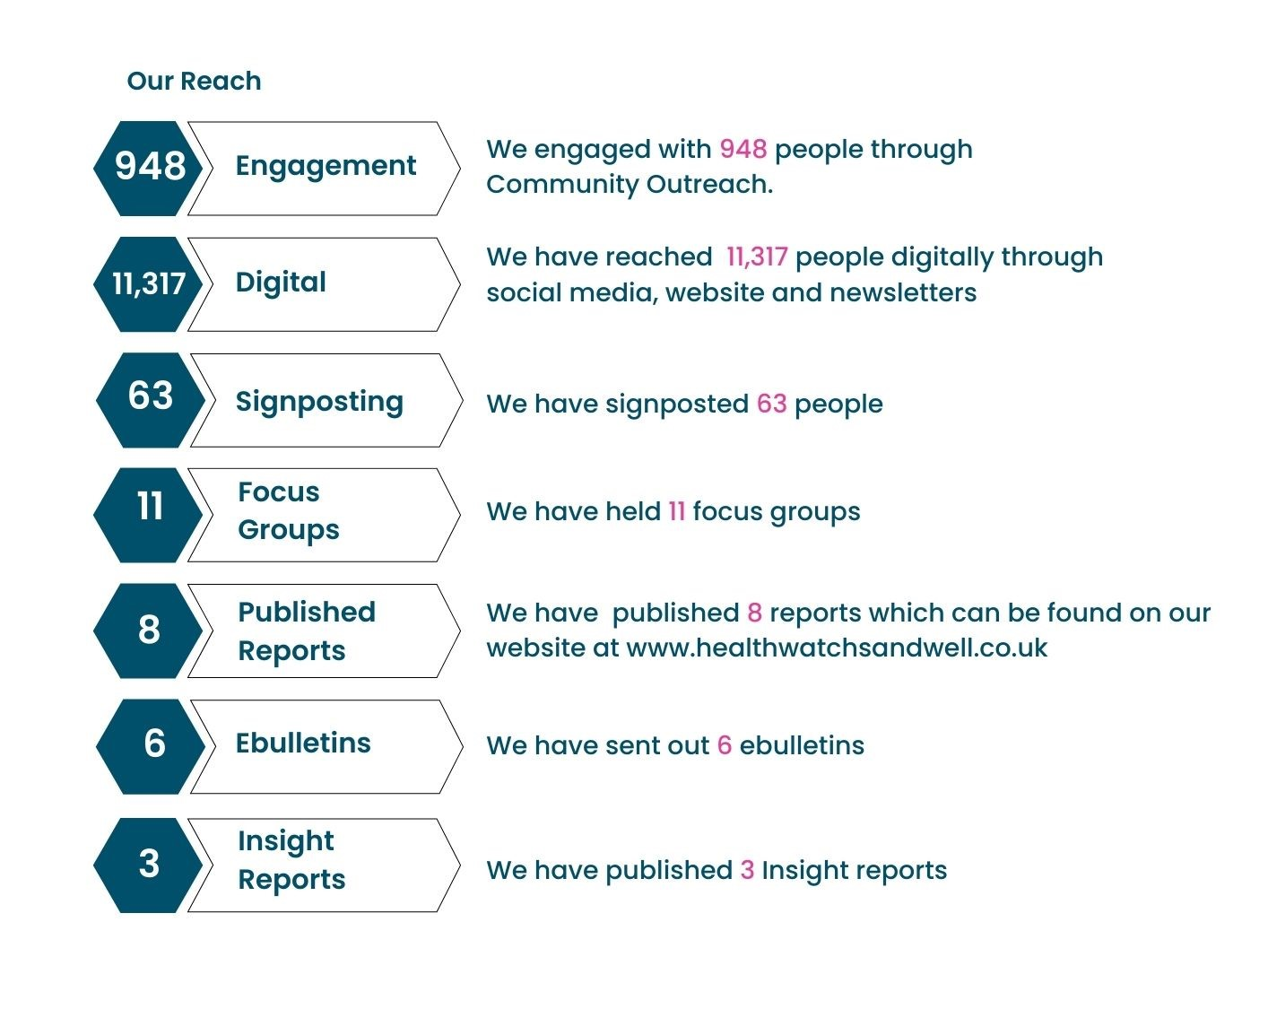

Plans
I aim to up the social media reach again, hopefully by the next HAB I can have moved it up by 10-20%
I aim to be posting more content over the coming months to engage more.

