

**Diabetes in Sandwell – Healthwatch Sandwell report Impact Review**

**Introduction**

Healthwatch Sandwell published a report [Diabetes in Sandwell](https://www.healthwatchsandwell.co.uk/sites/healthwatchsandwell.co.uk/files/2024%20Diabetes%20Main%20Report%20NEW%20pdf_0.pdf) in March 2024.

**10.1%** of Sandwell adult patients are recorded as having diabetes, exceeding West Midlands National average figures, projection are that it diabetes in Sandwell will continue to rise.

The report highlighted that raising awareness of diabetes in communities and prevention work with patients diagnosed as prediabetic is key to minimising risk of development of type 2 diabetes and reducing the percentage of patients with diabetes in Sandwell and consequent demand on diabetes health care services.

**The report recommendations included:**

* Increased information promotion, awareness raising and education on diabetes and risks
* A holistic partnership approach to diabetes prevention and risk reduction services
* Improvements to health care services including staff diabetes awareness training
* A focus on meeting specific needs for groups at higher risk of developing diabetes or challenges with managing the condition (elderly vulnerable population and Black and South Asian ethnic communities)
* Increases in support services for individuals and communities living with and managing diabetes.

**The report findings were well received - some collaborative partnership working has begun.**

**This summary report takes a look at some of the activity and impact April – September 2024.**



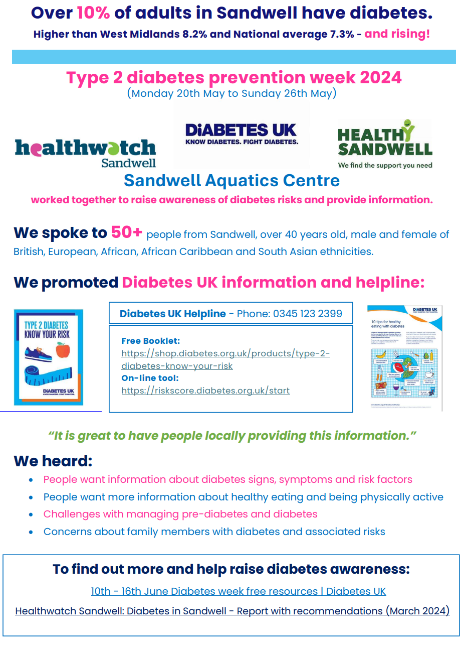

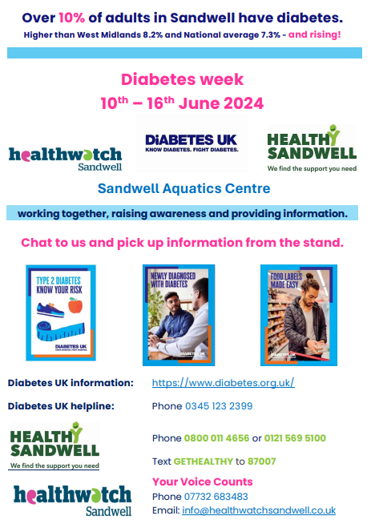

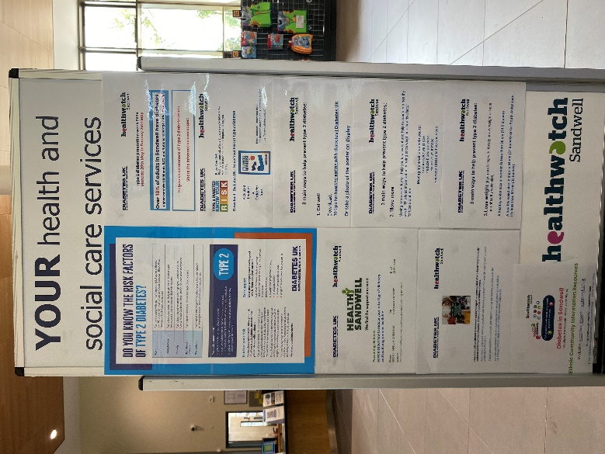



* **Spoke to over 70 people about diabetes**
* **Promoted Diabetes UK & Healthy Sandwell support & information**
* **Supported a health check event**
* **Talked about diabetes with a social group of elderly South Asian women**

**Other collaborative work and impact**

**Influenced** improvement plans for local diabetes prevention programme in communities.

**Collaborated** with the NHS Youth Worker Team Manager in Sandwell and West Birmingham NHS Trust to create a report to spotlight a youth worker pilot project for young people with long term conditions. The short funding timelines for the pilot project were highlighted alongside the impacts. The spotlight report called for consideration of extension and time and funding for the pilot project work.

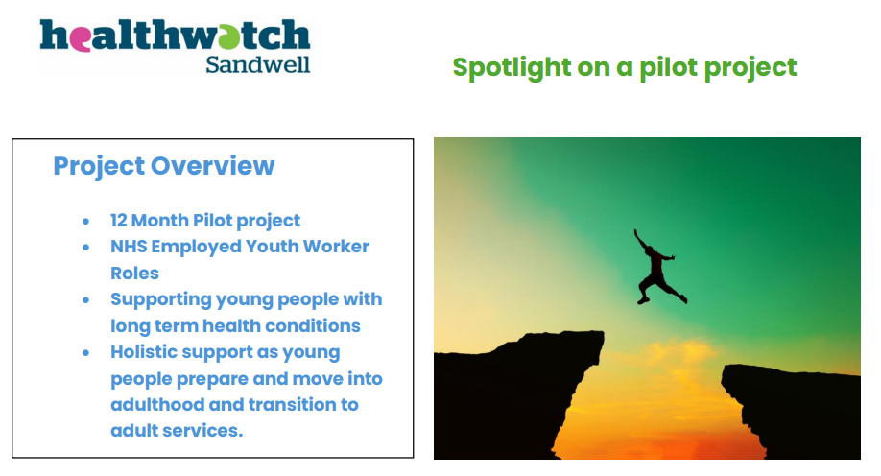

**Promoted**:

Diabetes UK published a report highlighting concerns about the increase in type 2 diabetes in children. [**Reverse the Trend - Reducing type 2 diabetes in young people - (May 2024) Diabetes UK**](https://diabetes-resources-production.s3.eu-west-1.amazonaws.com/resources-s3/public/2024-05/Reverse%20the%20Trend%20-%20Reducing%20type%202%20diabetes%20in%20young%20people.pdf)

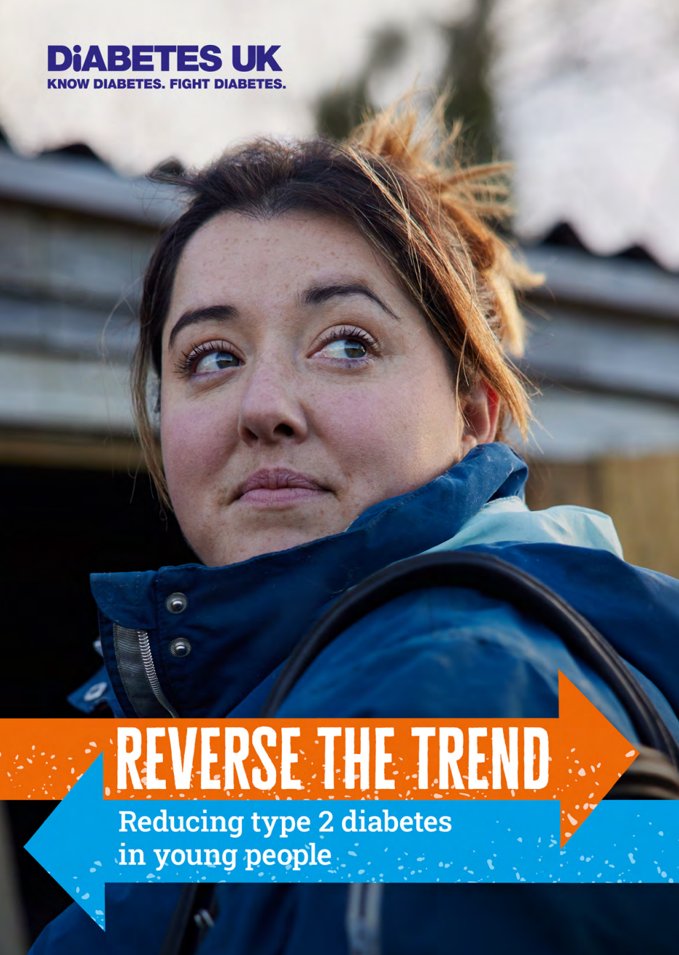

**When type 2 diabetes develops at a younger age, defined here as under 40, it is more acute and aggressive. It is associated with an increased risk, and more rapid onset, of devastating complications such as heart disease, kidney disease, sight loss, and even early death. Developing type 2 diabetes at a younger age can also bring additional challenges to managing blood glucose levels.**